Philip Pounds

Algebra 2

Exponential Project

Given the current events in the markets, I chose for my exponential project to track ETF(exchange traded fund) growth. The goal of this project is to predict how much one will have in 10 years from now if they invest $1000 into the Vanguard S&P 500 ETF (Ticker: VOO). I chose this ETF because it performs similar to the S&P 500 and has a lower capital requirements for full shares(VOO = 242.07 S&P 500 2663.68 ) Since no one can predict the market, we assume the ETF will perform similar to the past, and since this is a S&P 500 ETF, we assume a 9.8% annual return. Also, the expense ratio of .03% will be factored out. The equation will look like this:

Value = Amount* (1 + Annual Growth)Time or Y=A(B)x

Time = 10 years Amount = $1000 Annual Growth = 9.8% or .098%

Value = $1000(1.098)10 years Value = $2546.97 - $30 expense ratio(.03% initial investment yearly)

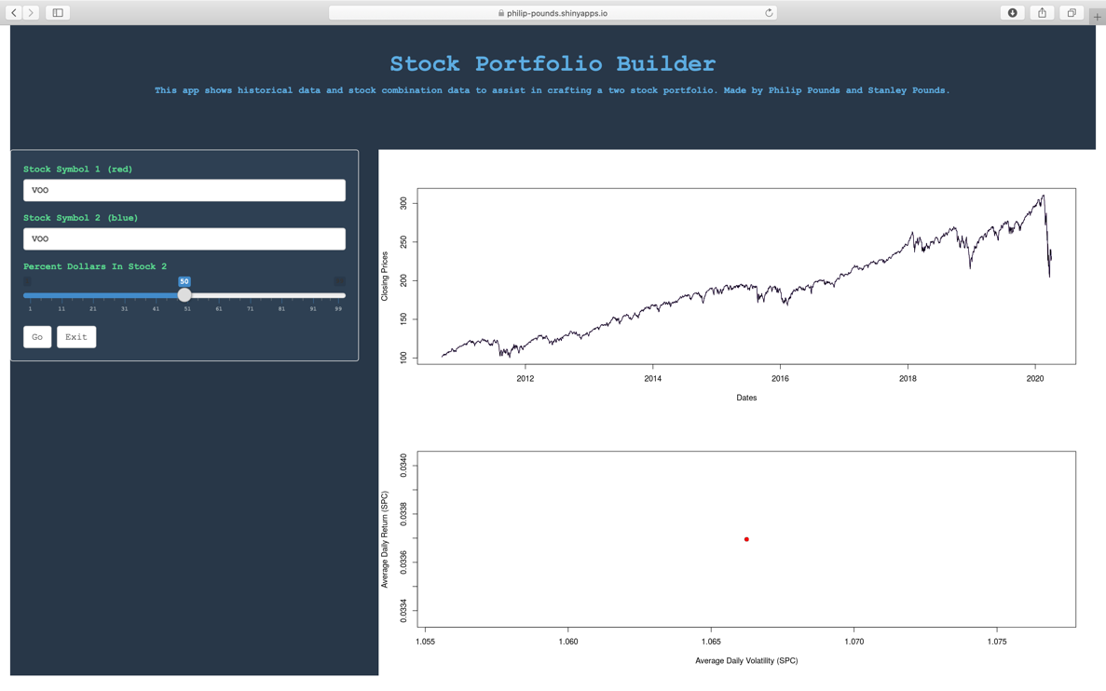

(Picture of VOOs past performance from <https://philip-pounds.shinyapps.io/TheStockApp/>)

We can conclude that a $1000 investment into VOO will be worth **$2516.97** in 10 years (subtracting out expense ratio fees).